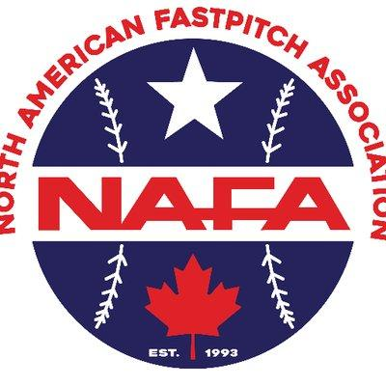
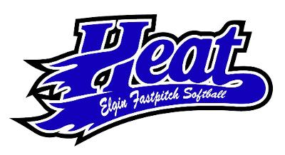

ELGIN HEAT SOFTBALL PRESENTS
26th ANNUAL ELGIN HEAT CLASSIC
@THE ELGIN SPORTS COMPLEX
JUNE 4-6, 2021
2021 NAFA ILLINOIS QUALIFIER
12U, 14U, 16U, 18U, AGE LEVELS

- 4gg (weather permitting 1 game fulfills tournament)
- 80 minute games finish the inning
- 2021 NAFA Rules will apply to all games
- NAFA Midwest &/OR Northern National Bids
- Awards
- Team awards for top 2 teams of each age group
- Individual awards for 1st & 2nd place team at each age level
- Tournament will begin on Friday June 4th
- All games are played at the Elgin Sports Complex, 709 Sports Way, Elgin, IL
- Tournament fee $550 if paid by February 1st, only pay $525.
$100 fee is retained for complete tournament rainout. No refunds after acceptance unless spot is filled.
- All teams must be NAFA registered. Please register at www.nafasoftball.com
- Mandatory online registration @ www.elginheatsoftball.org checks will be accepted however the deadline for checks is March 1st, 2021. If your check is not received by March 1st, your team will be waitlisted and we cannot hold your spot.

- If paying by check you must register online first and send your
check to 9N491 Hobart Drive, Elgin, IL 60123. Any questions email Steve Cooper@heatcoachcoop@aol.com or 224-629-6281

